**11.1 Simple Autoencoder**

**11.1.1 Changing learning rate**

Constant parameters:

Optimizer = AdagradOptimizer

Training steps = 6

Table: losses for each iteration

|  |  |  |  |  |  |  |  |
| --- | --- | --- | --- | --- | --- | --- | --- |
| Training rate | Step 0 | Step 1 | Step 2 | Step 2 | Step 4 | Step 5 | Step6 |
| 0.1 | 0.745 | 0.260 | 0.257 | 0.246 | 0.227 | 0.212 | 0.2139 |
| 0.5 | 0.662 | 0.219 | 0.178 | 0.161 | 0.161 | 0.145 | 0.1397 |
| 0.75 | 0.646 | 0.191 | 0.157 | 0.146 | 0.135 | 0.124 | 0.1246 |
| 1.0 | 0.625 | 0.180 | 0.148 | 0.133 | 0.118 | 0.117 | 0.1138 |

Training rate 0.1

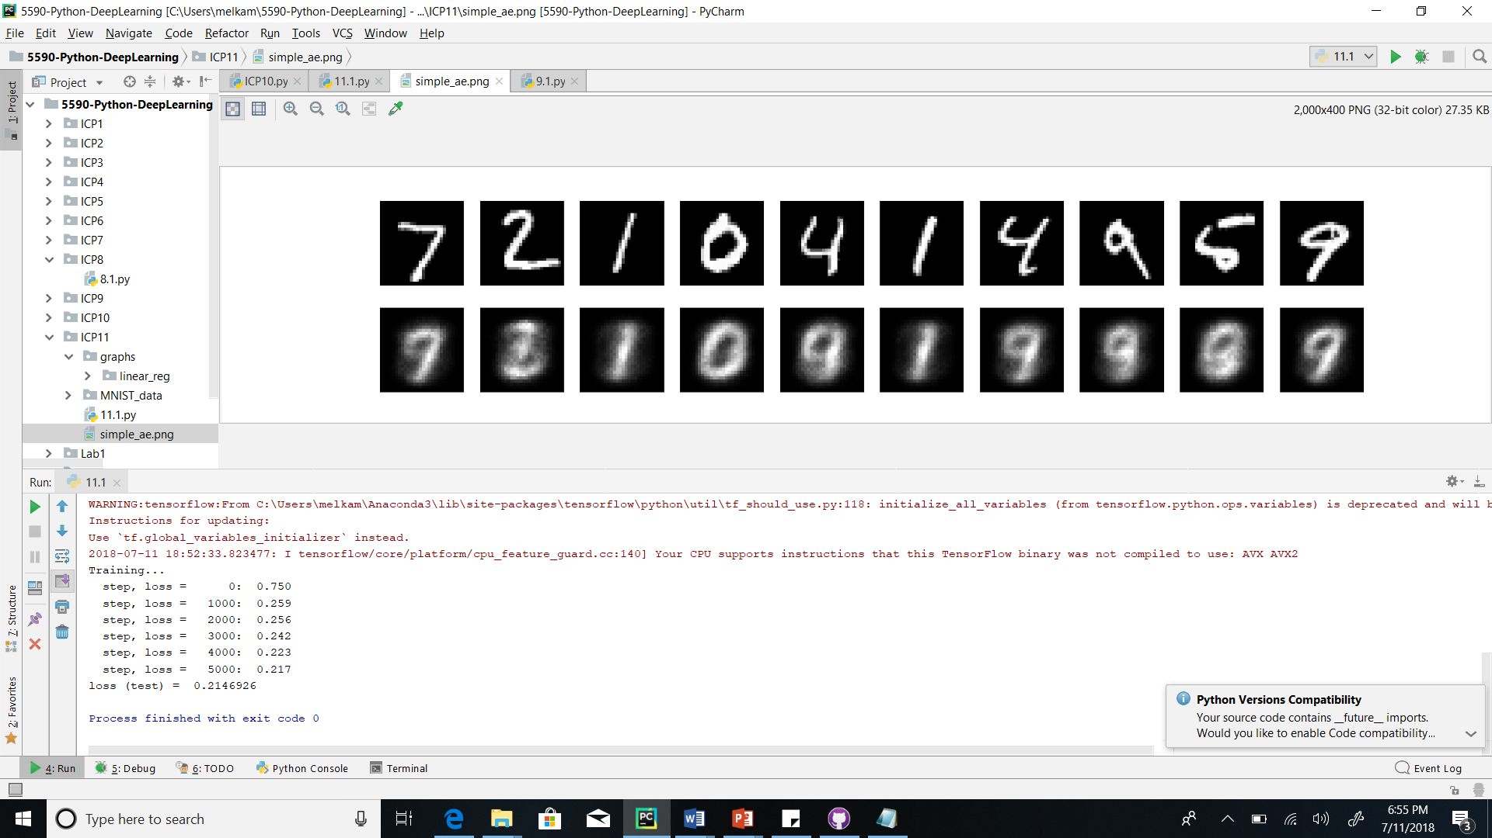

Training rate 1.0

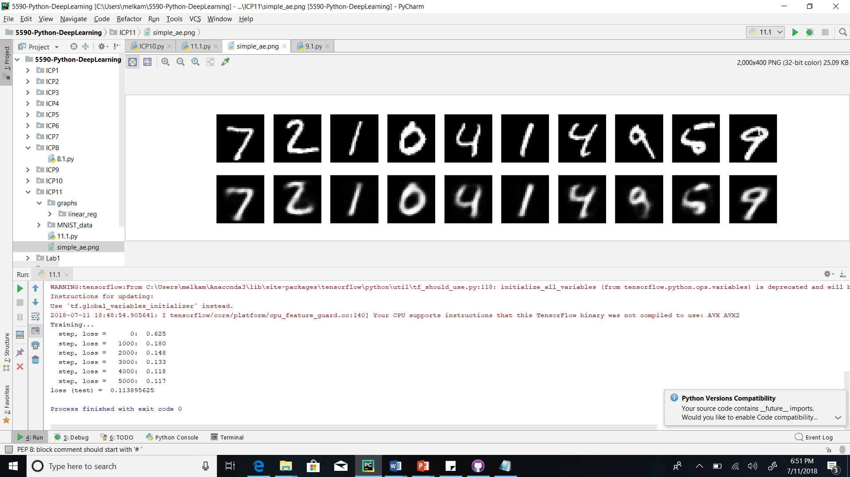

**Conclusion: Increasing training rate will minimize loss.**

**11.1.2 Changing optimizer**

Constant parameters:

Training rate = 1.0

Training steps = 6

|  |  |  |  |  |  |  |  |
| --- | --- | --- | --- | --- | --- | --- | --- |
| Optimizer | Step 0 | Step 1 | Step 2 | Step 3 | Step 4 | Step5 | Step6 |
| AdagradOptimizer | 0.625 | 0.180 | 0.148 | 0.133 | 0.118 | 0.117 | 0.1138 |
| GradientDecentOptimizer | 0.717 | 0.240 | 0.207 | 0.188 | 0.169 | 0.159 | 0.1591 |
| RMSPropOptimizer | 0.704 | Nan | Nan | Nan | Nan | Nan | Nan |
| AdamOptimizer | Nan | Nan | Nan | Nan | Nan | Nan | Nan |

AdagradOptimizer



GradientDecentOptimizer

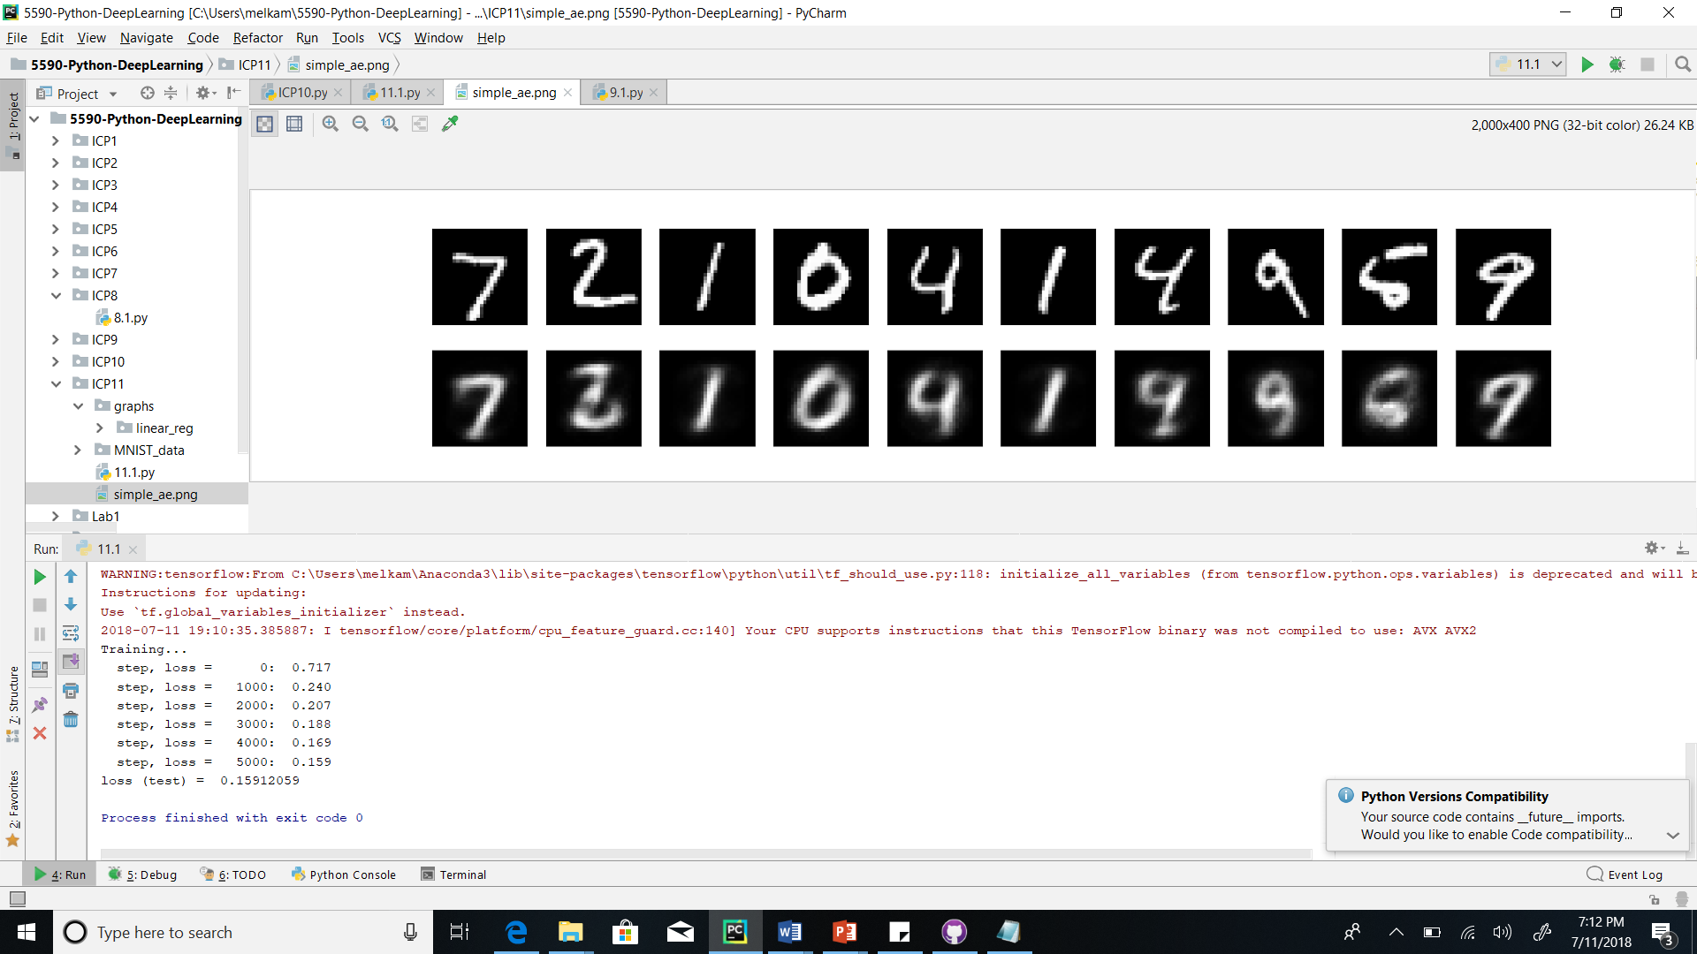

RMSPropOptimizer

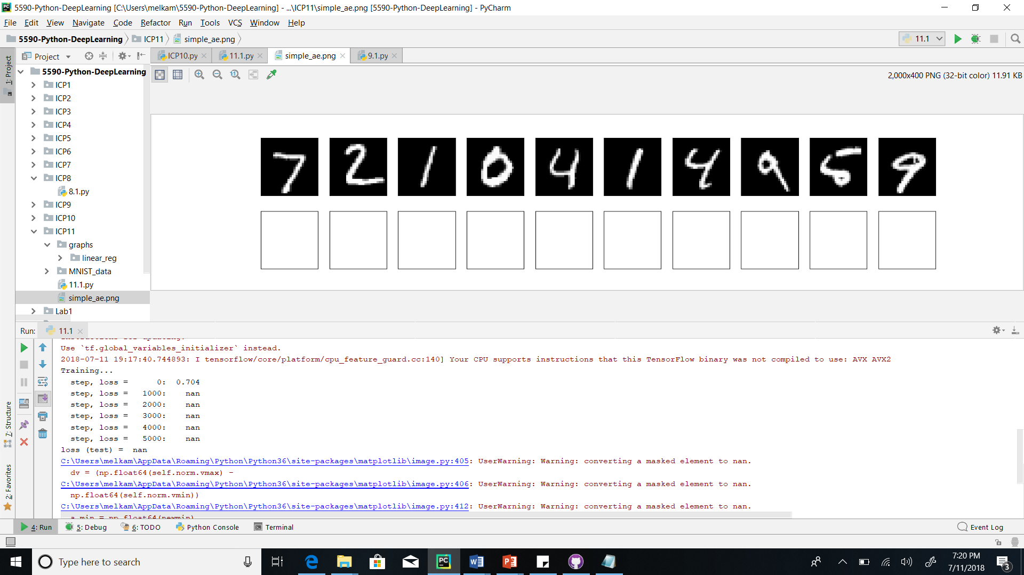

AdamOptimizer



**Conclusion: AdagradOptimizer works best for this case**

**11.1.3 Changing steps/iteration**

Constant parameters:

Training rate = 1.0

Optimizer = AdagradOptimizer

|  |  |  |  |  |  |  |  |  |  |  |  |  |
| --- | --- | --- | --- | --- | --- | --- | --- | --- | --- | --- | --- | --- |
| Steps | Step  0 | Step1 | Step2 | Step3 | Step4 | Step  5 | Step 6 | Step7 | Step8 | Step9 | Step  10 | Net loss |
| 3 | 0.645 | 0.175 | 0.147 |  |  |  |  |  |  |  |  | 0.1489 |
| 5 | 0.637 | 0.179 | 0.147 | 0.137 | 0.123 |  |  |  |  |  |  | 0.1218 |
| 6 | 0.622 | 0.186 | 0.150 | 0.135 | 0.126 | 0.116 |  |  |  |  |  | 0.1140 |
| 8 | 0.624 | 0.183 | 0.148 | 0.141 | 0.124 | 0.109 | 0.109 | 0.110 |  |  |  | 0.1033 |
| 10 | 0.632 | 0.179 | 0.148 | 0.131 | 0.125 | 0.111 | 0.111 | 0.105 | 0.099 | 0.101 | 0.096 | 0.0941 |

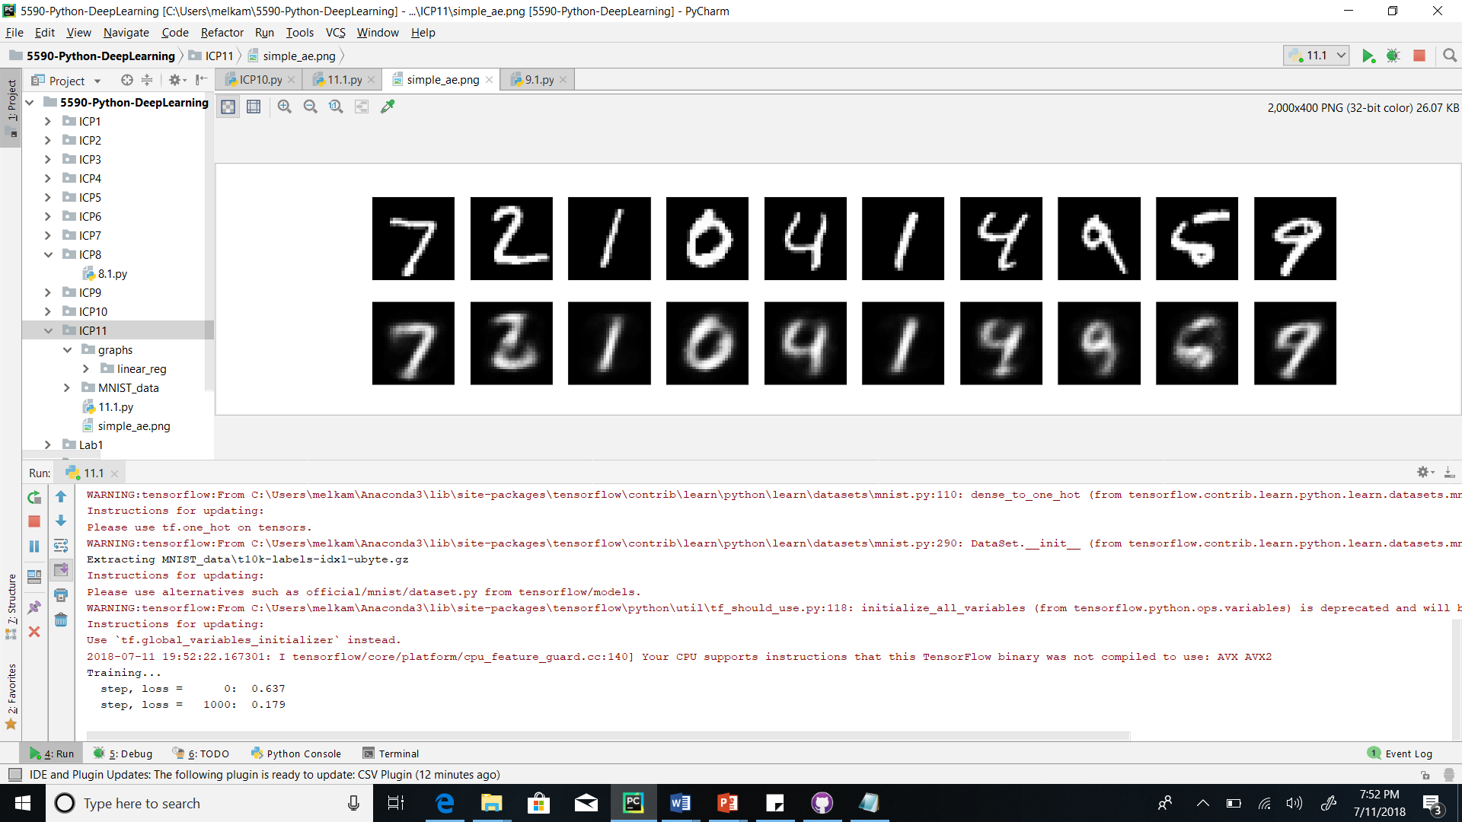

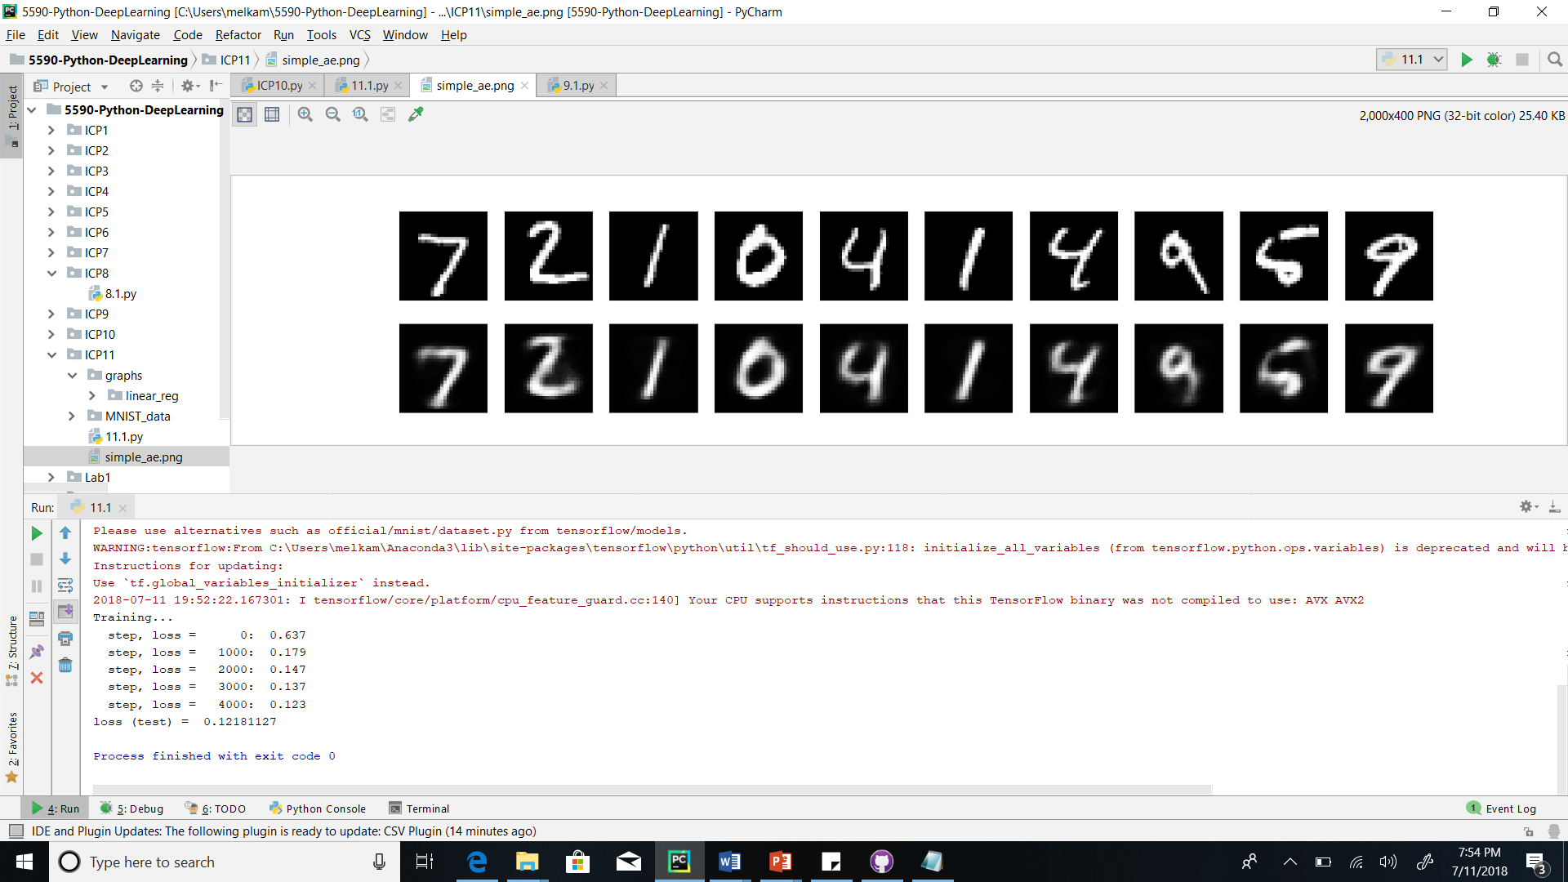



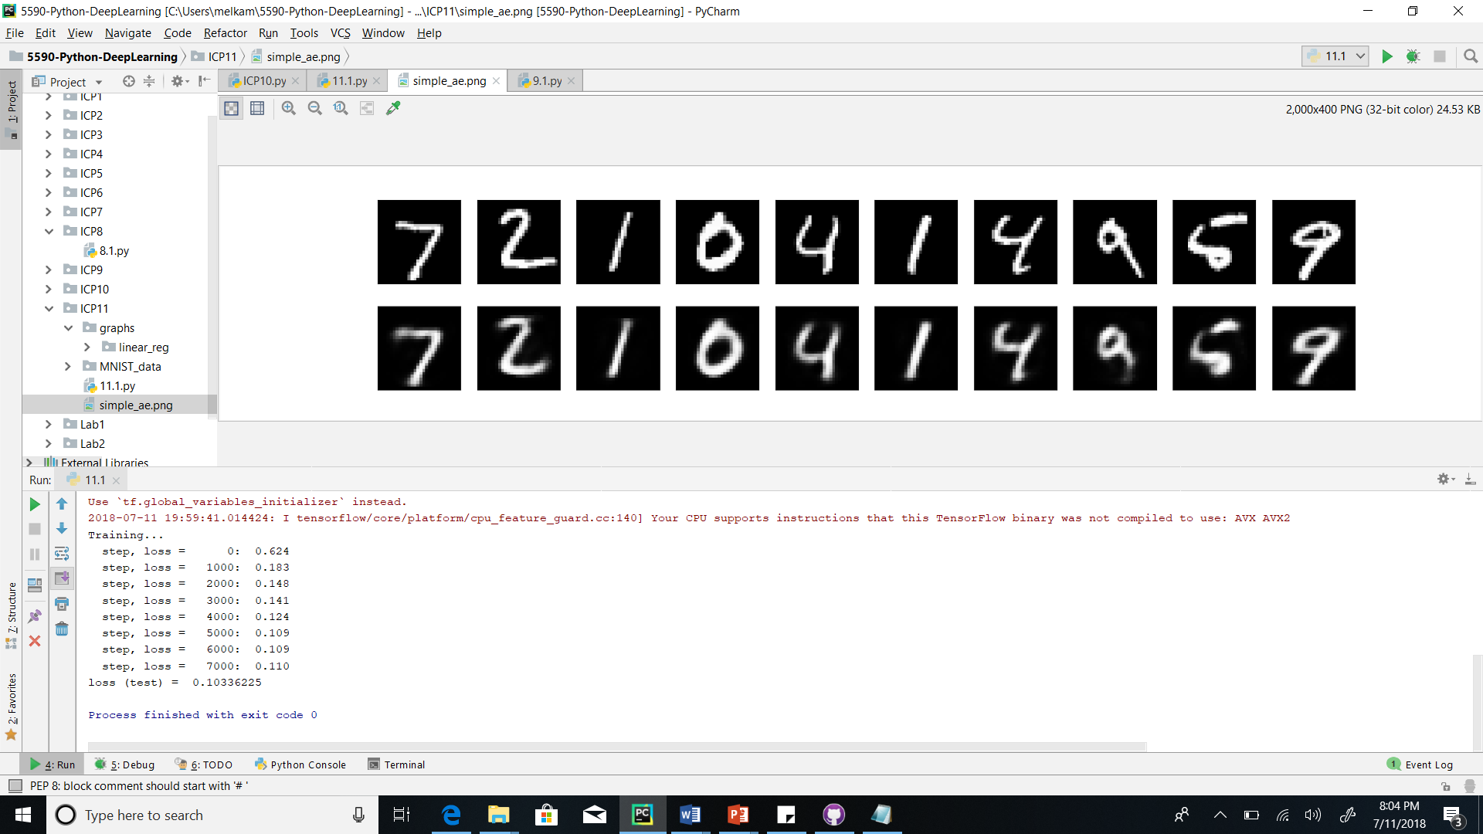

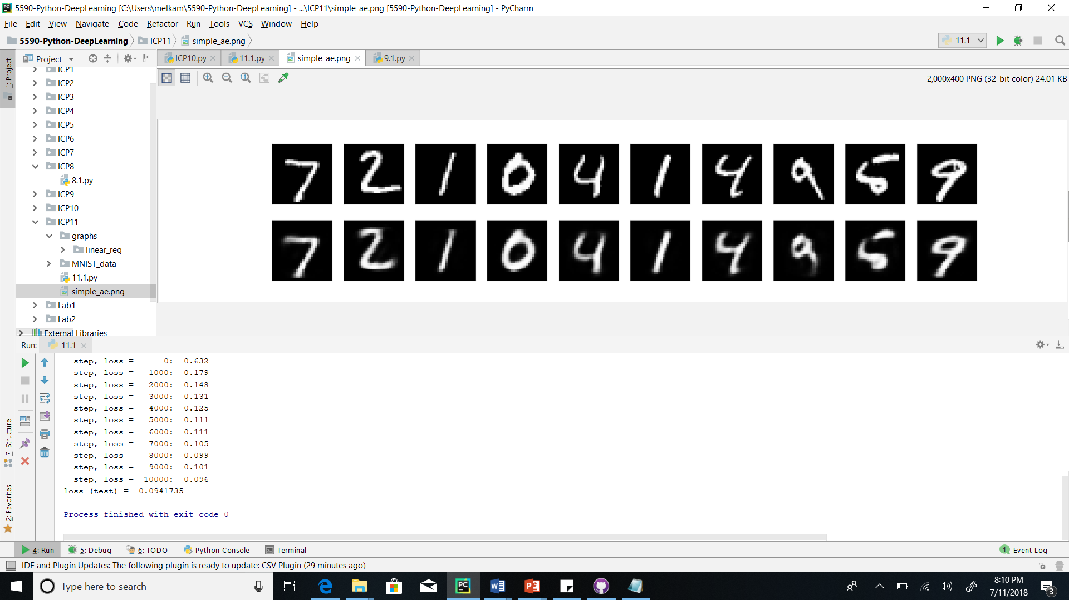

**Conclusion: Increasing iteration/number of steps will minimize loss**

**11.2 Stacked Autoencoder**

**11.2.1 Changing learning rate**

Constant parameters:

Optimizer = RMSPropOPtimizer

Training steps = 6

Table: losses for each iteration

|  |  |  |  |  |  |  |  |
| --- | --- | --- | --- | --- | --- | --- | --- |
| Learning rate | Step 0 | Step 1 | Step 2 | Step 3 | Step 4 | Step 5 | Step 6 |
| 0.001 | 0.454 | 0.176 | 0.163 | 0.148 | 0.142 | 0.140 | 0.1337 |
| 0.01 | 0.434 | 0.129 | 0.105 | 0.102 | 0.092 | 0.090 | 0.083 |
| 0.1 | 0.451 | 0.179 | 0.175 | 0.169 | 0.166 | 0.169 | 0.167 |
| 1.0 | 0.440 | 0.183 | 0.187 | 0.186 | 0.188 | 0.187 | 0.188 |

Training rate 0.001

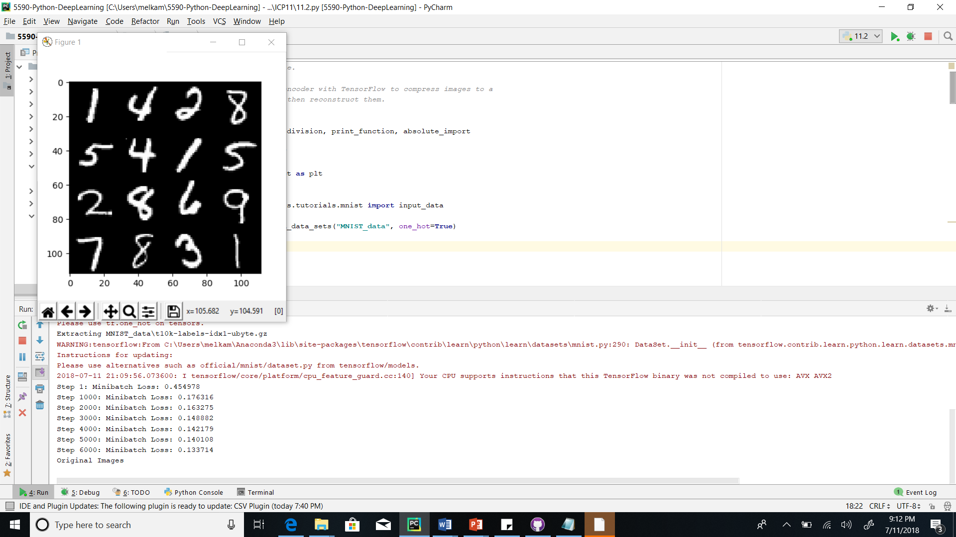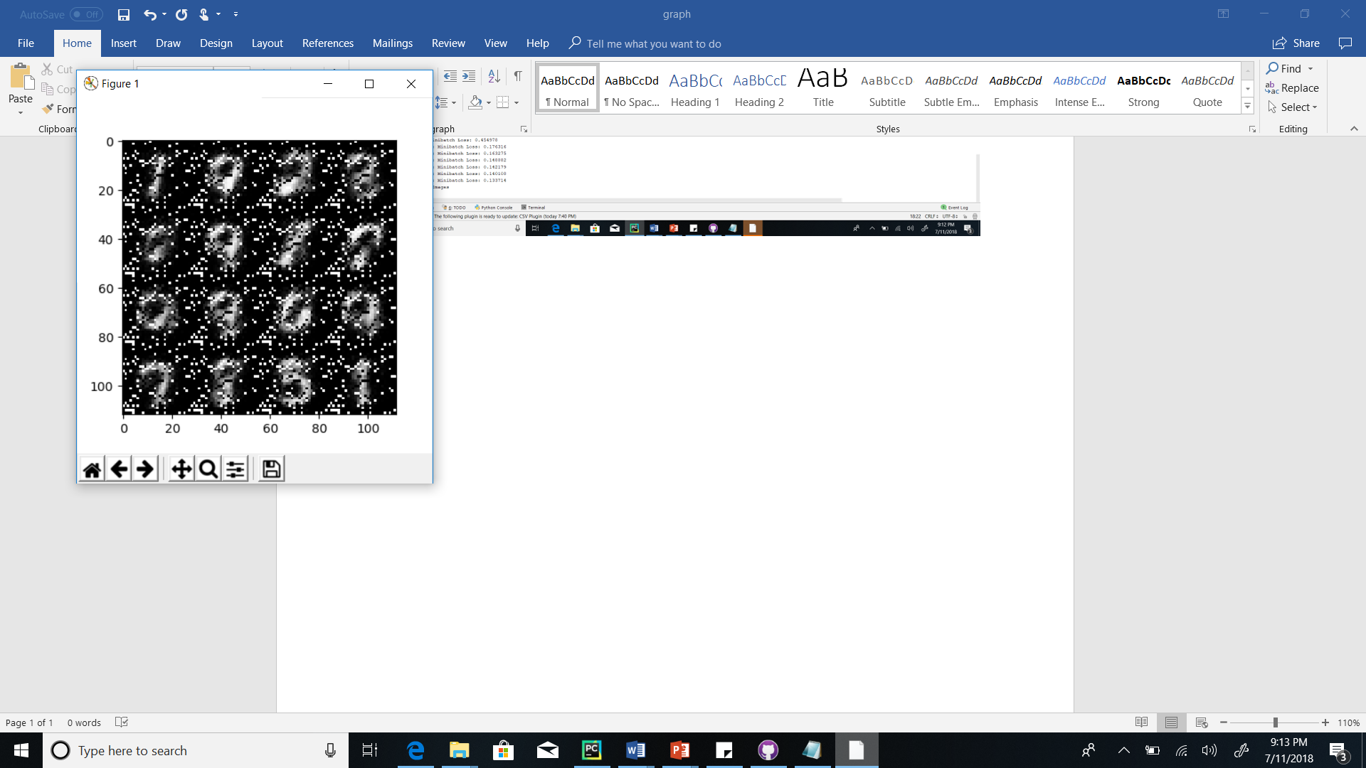

Training rate 0.01

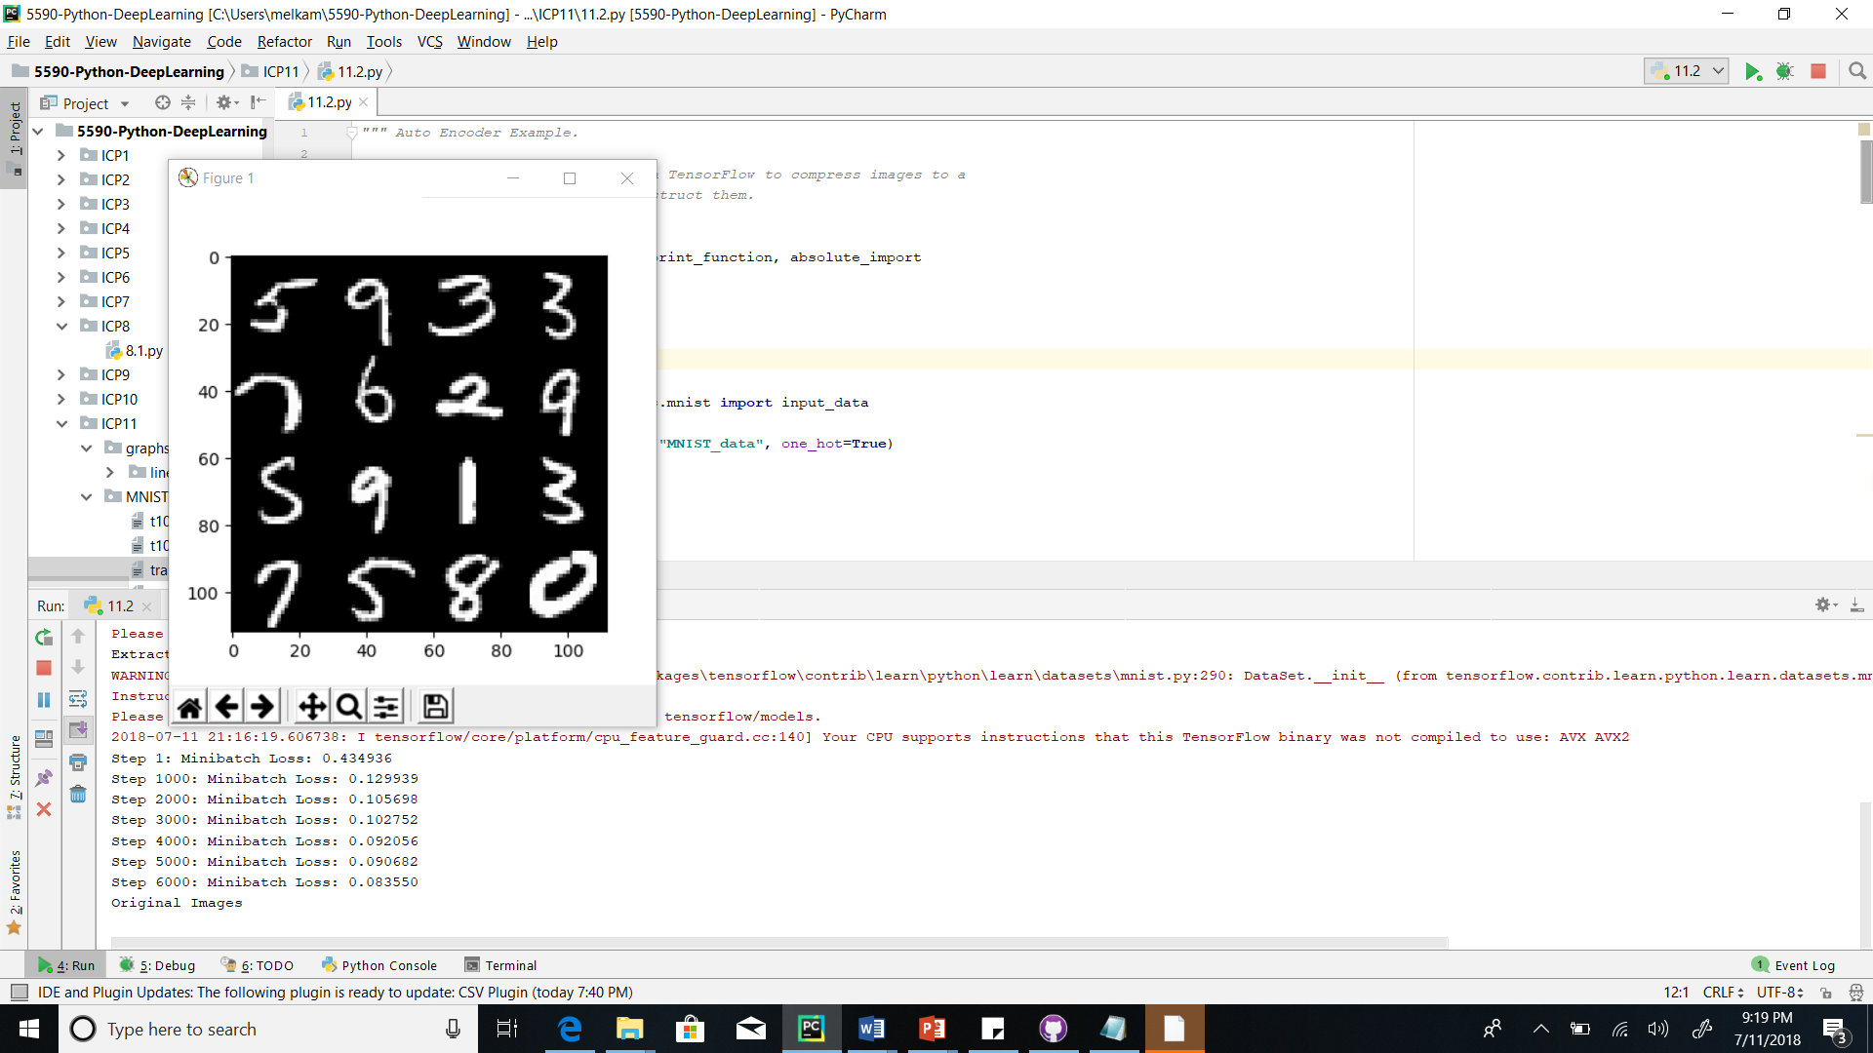

Training rate 0.1

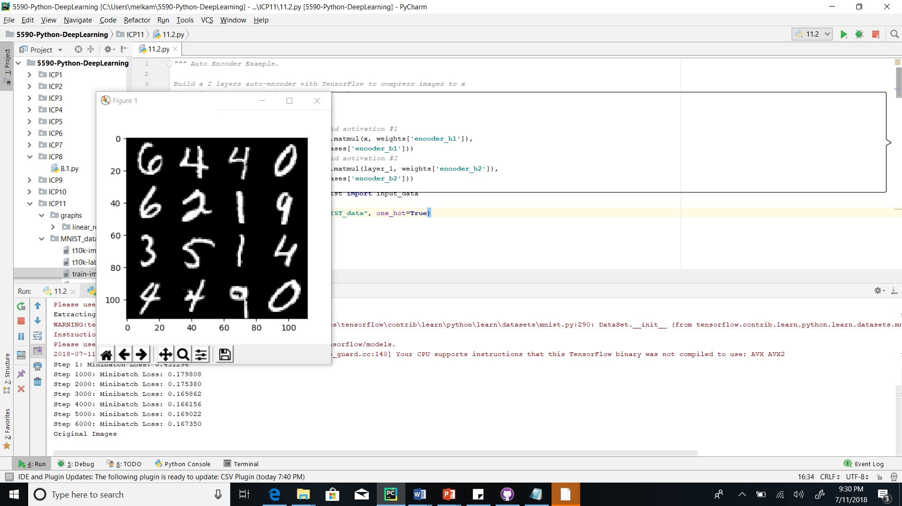

Training rate 1.0

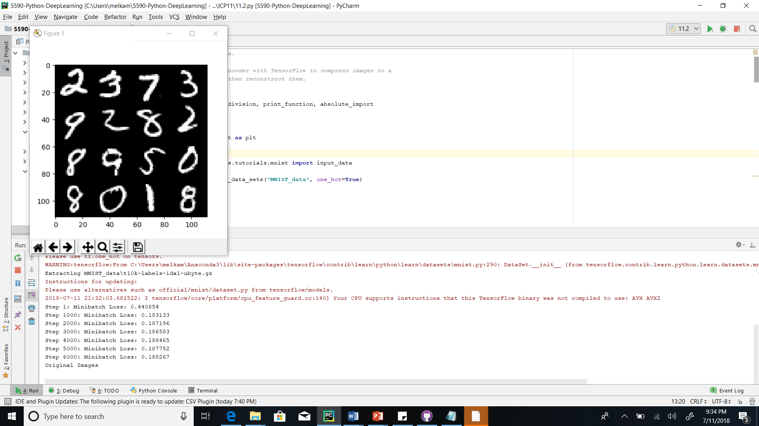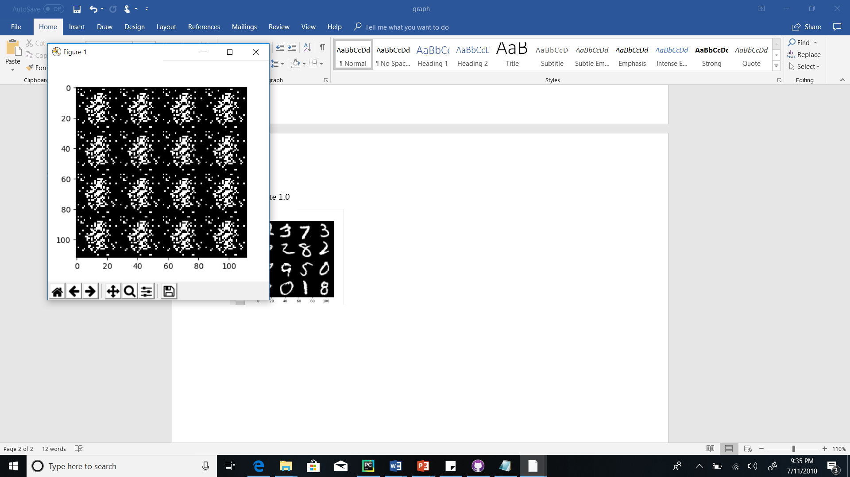

Conclusion: The best result was obtained when the learning rate was 0.01

**11.2.2 Changing optimizer**

Constant parameters:

Training rate = 0.01

Training steps = 6

|  |  |  |  |  |  |  |  |
| --- | --- | --- | --- | --- | --- | --- | --- |
| Optimizer | Step 0 | Step 1 | Step 2 | Step 3 | Step 4 | Step5 | Step6 |
| AdagradOptimizer | 0.457 | 0.446 | 0.435 | 0.424 | 0.415 | 0.405 | 0.394 |
| GradientDecentOptimizer | 0.432 | 0.429 | 0.426 | 0.421 | 0.419 | 0.414 | 0.410 |
| AdamOptimizer | 0.439 | 0.067 | 0.060 | 0.056 | 0.053 | 0.054 | 0.053 |
| RMSPropOptimizer | 0.434 | 0.129 | 0.105 | 0.102 | 0.092 | 0.090 | 0.083 |

AdagradOptimizer

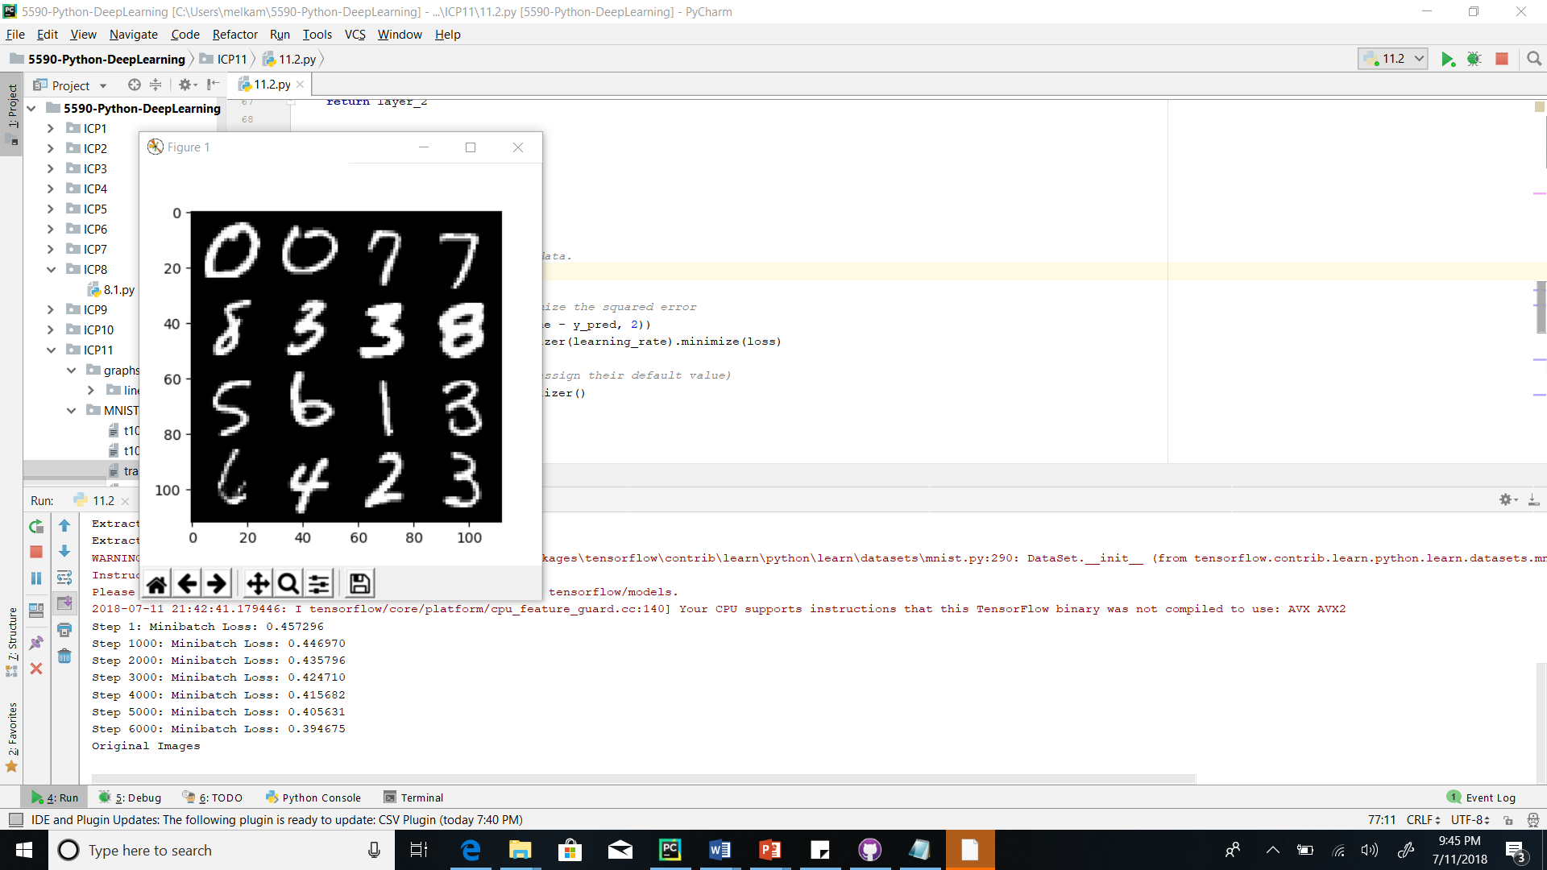

GradientDecentOPtimizer

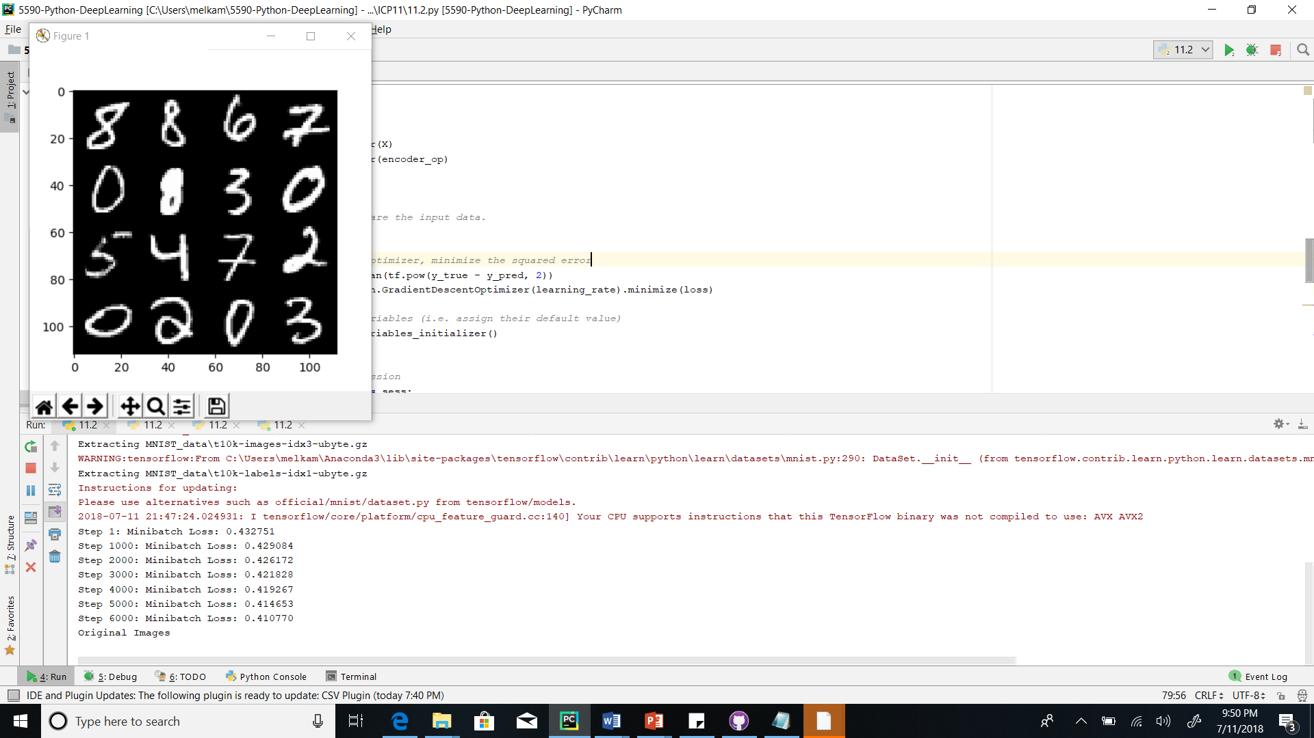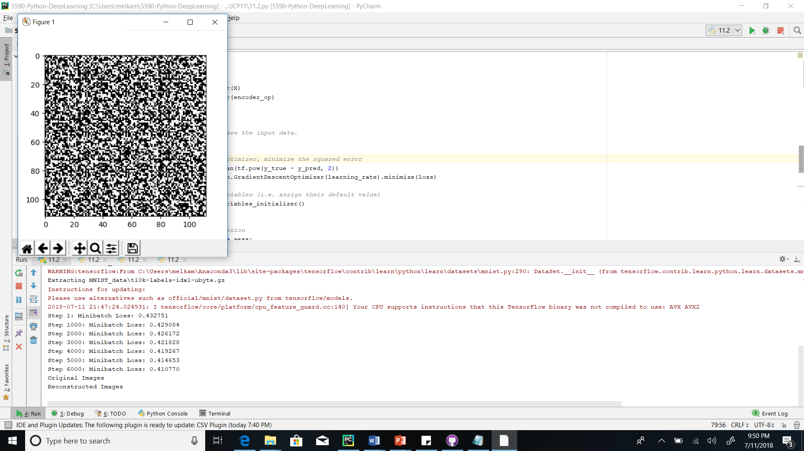

AdamOptimizer

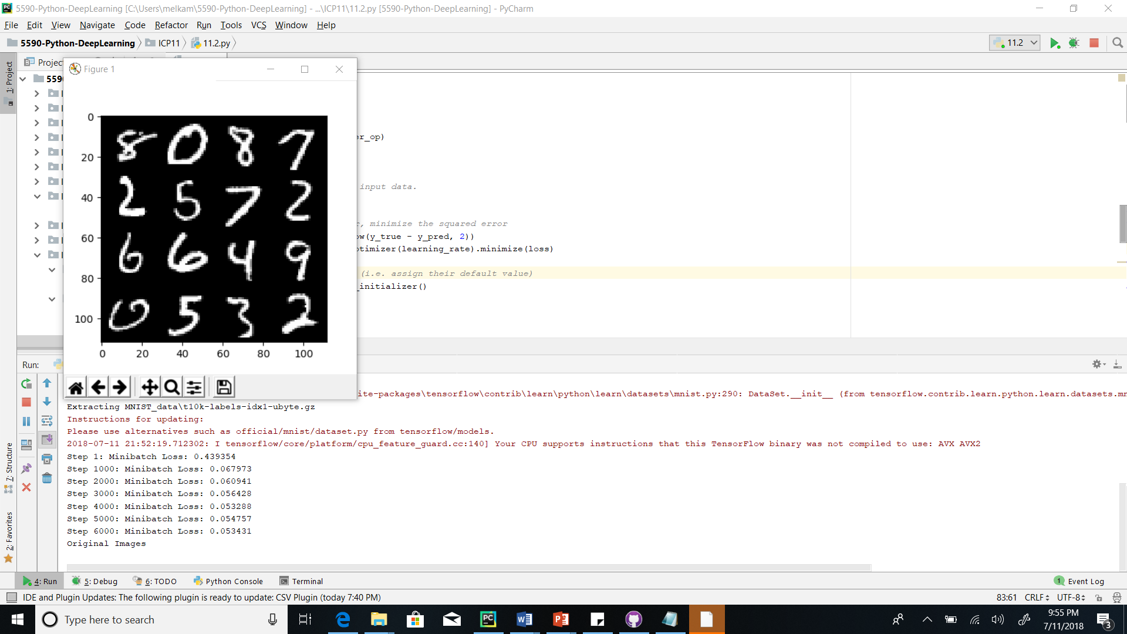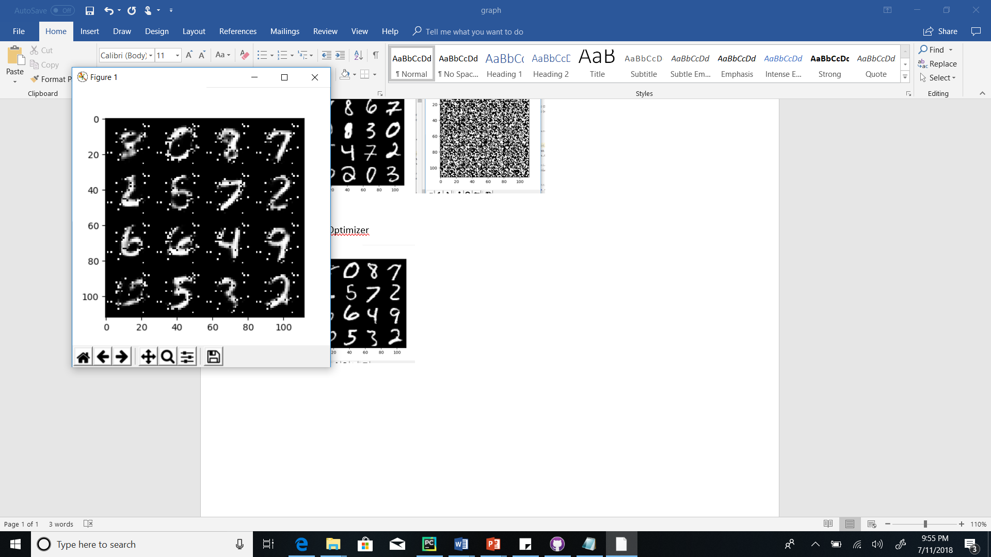

RMSPropOptimizer



**Conclusion**: AdamOPtimizer and RMSOptimizer will give the best result

**11.2.3 Changing steps/iteration**

Constant parameters:

Training rate = 0.01

Optimizer = RMSPropOptimizer

|  |  |  |  |  |  |  |  |  |  |  |  |  |
| --- | --- | --- | --- | --- | --- | --- | --- | --- | --- | --- | --- | --- |
| Steps | Step  0 | Step1 | Step2 | Step3 | Step4 | Step  5 | Step 6 | Step7 | Step8 | Step9 | Step  10 | Step11 |
| 6 | 0.436 | 0.153 | 0.129 | 0.120 | 0.112 | 0.104 | 0.099 |  |  |  |  |  |
| 7 | 0.432 | 0.125 | 0.108 | 0.101 | 0.096 | 0.089 | 0.086 | 0.082 |  |  |  |  |
| 8 | 0.437 | 0.145 | 0.128 | 0.123 | 0.112 | 0.108 | 0.101 | 0.098 | 0.094 |  |  |  |
| 9 | 0.441 | 0.150 | 0.125 | 0.116 | 0.108 | 0.105 | 0.101 | 0.096 | 0.094 | 0.094 |  |  |
| 10 | 0.443 | 0.131 | 0.118 | 0.107 | 0.101 | 0.099 | 0.097 | 0.094 | 0.090 | 0.088 | 0.083 | 0.082 |

Number of iterations = 6

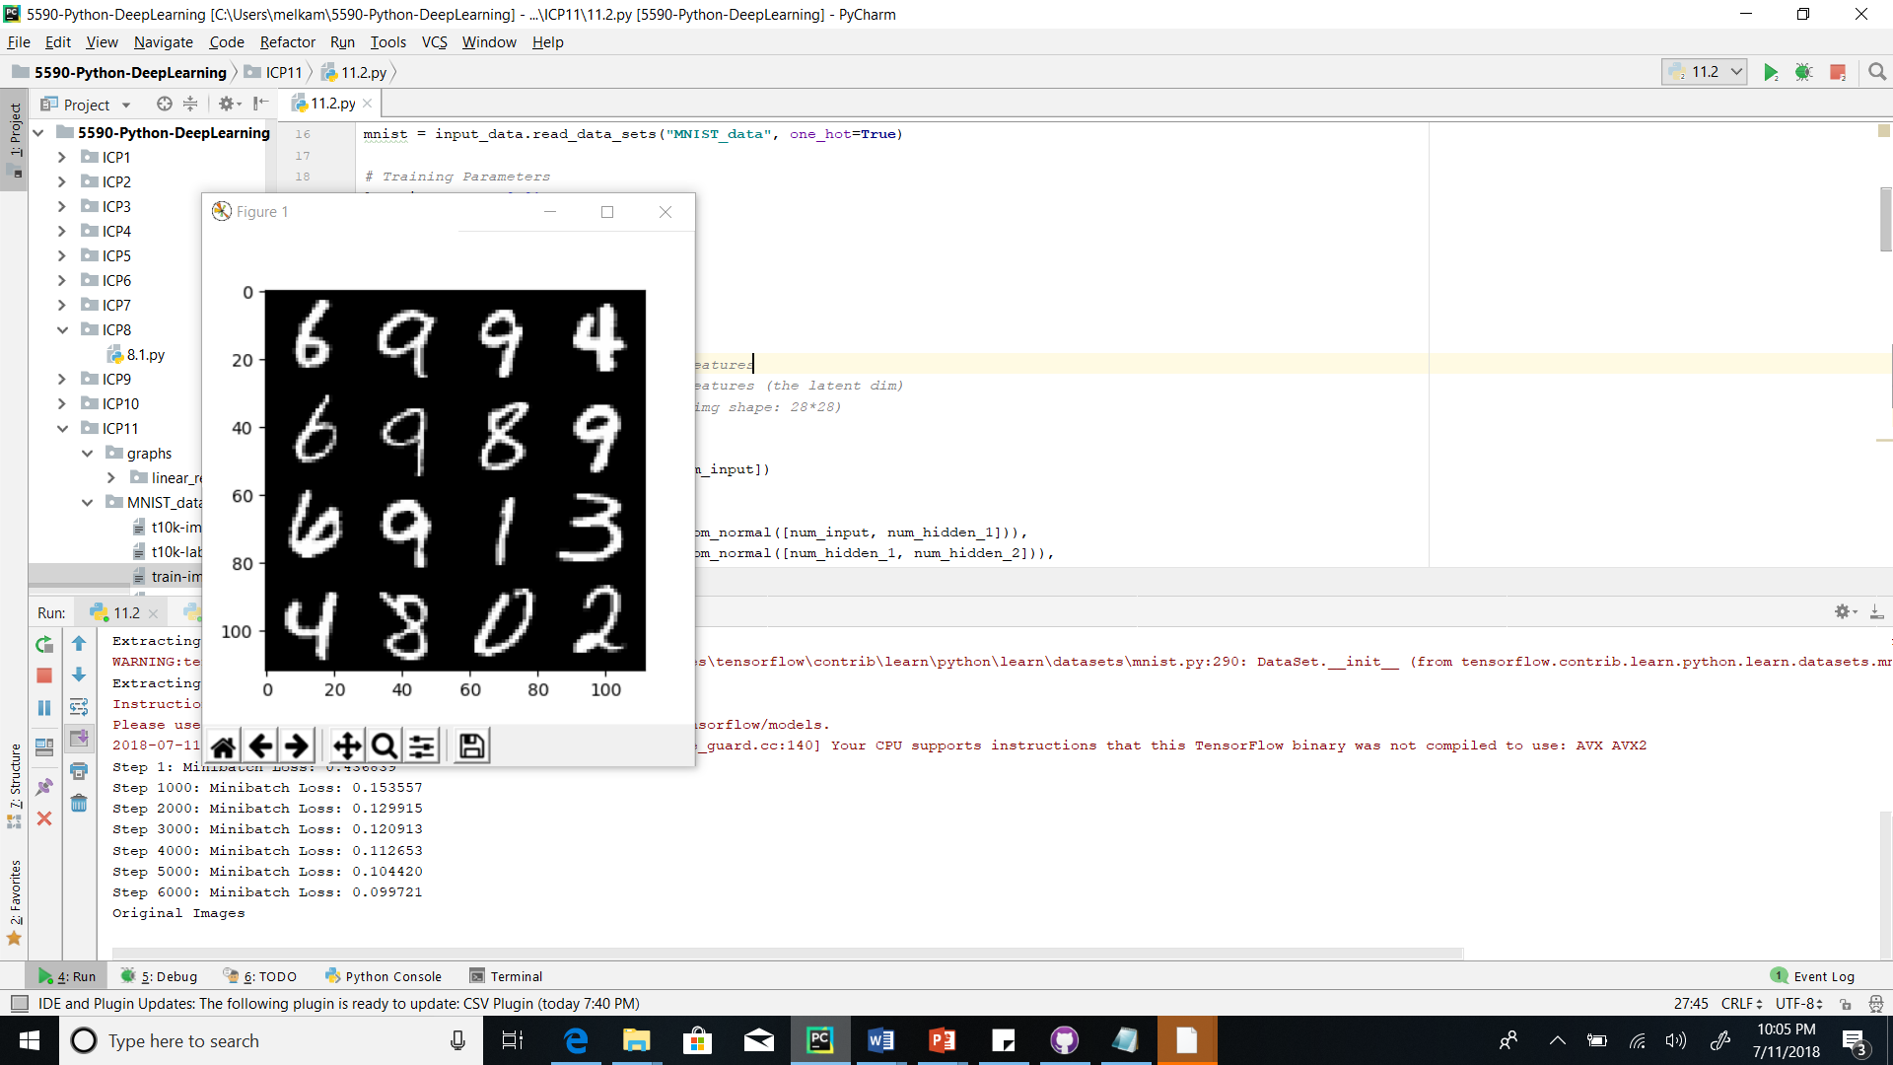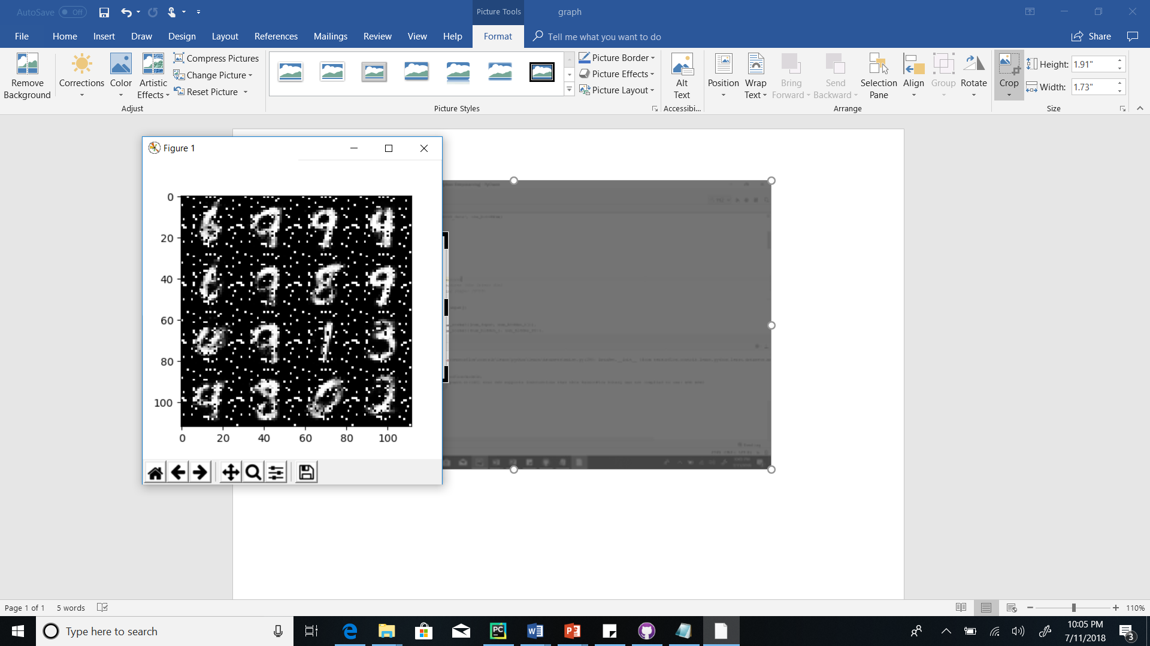

Number of iterations = 7

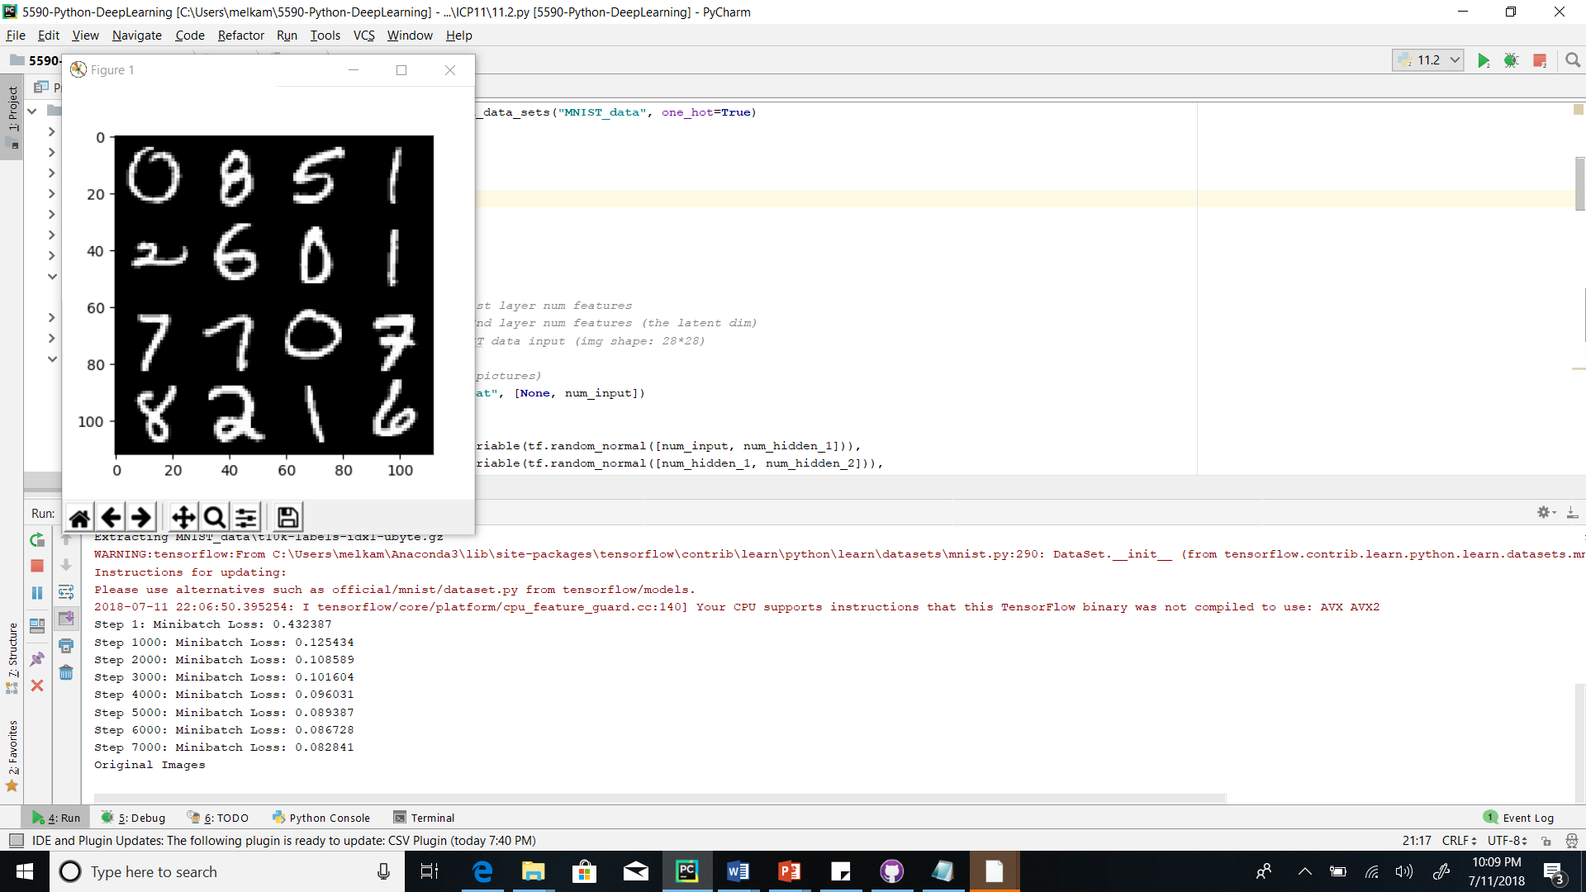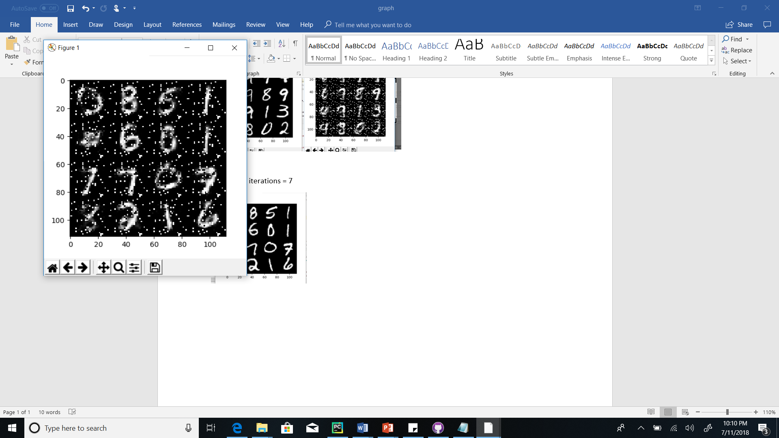

Number of iterations = 8

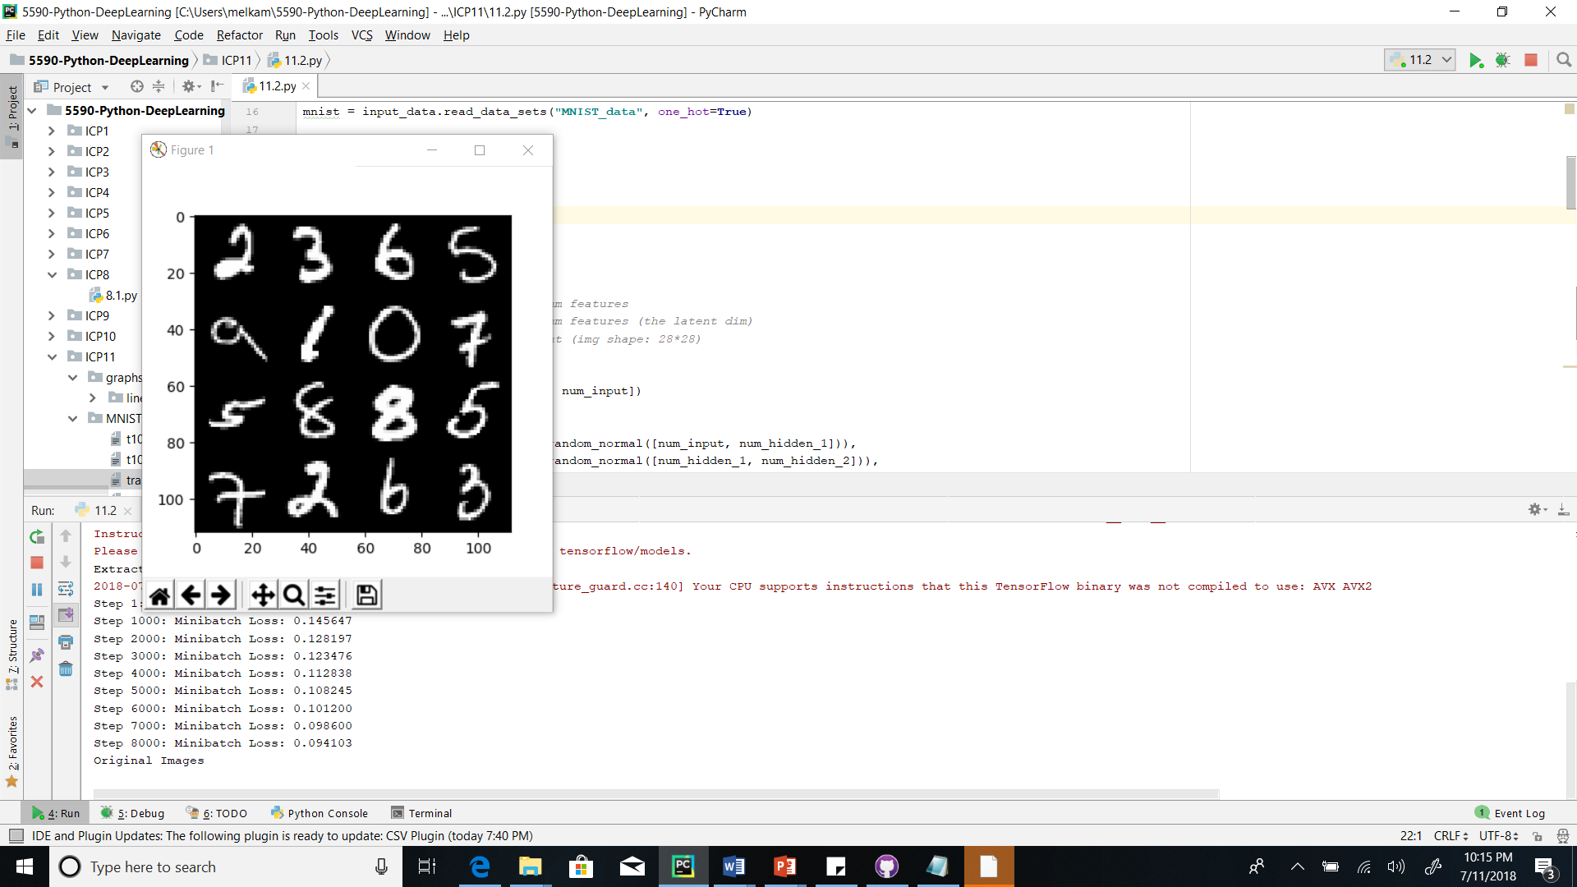

Number of iterations = 9

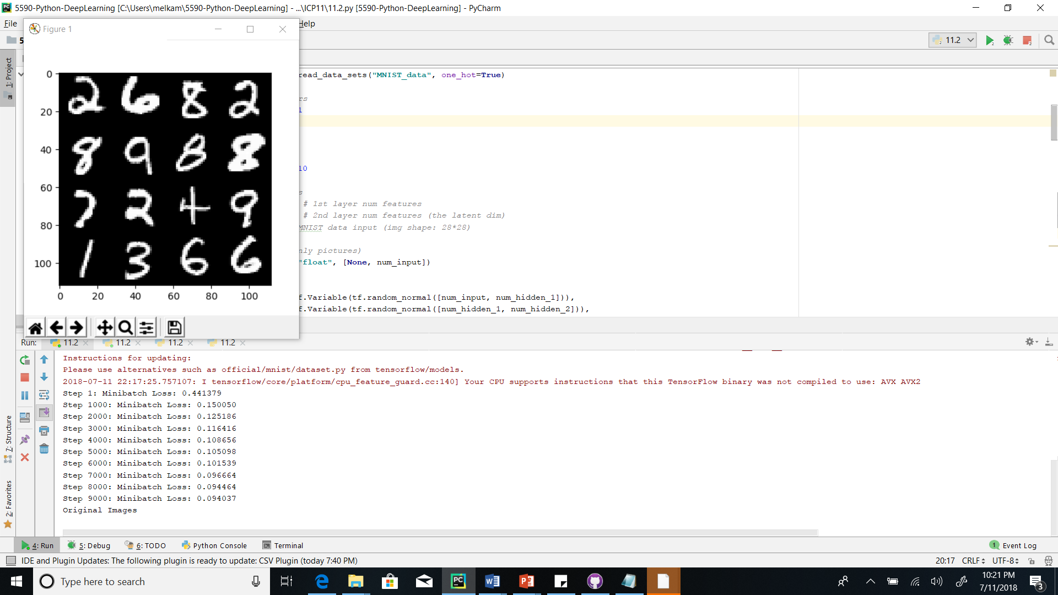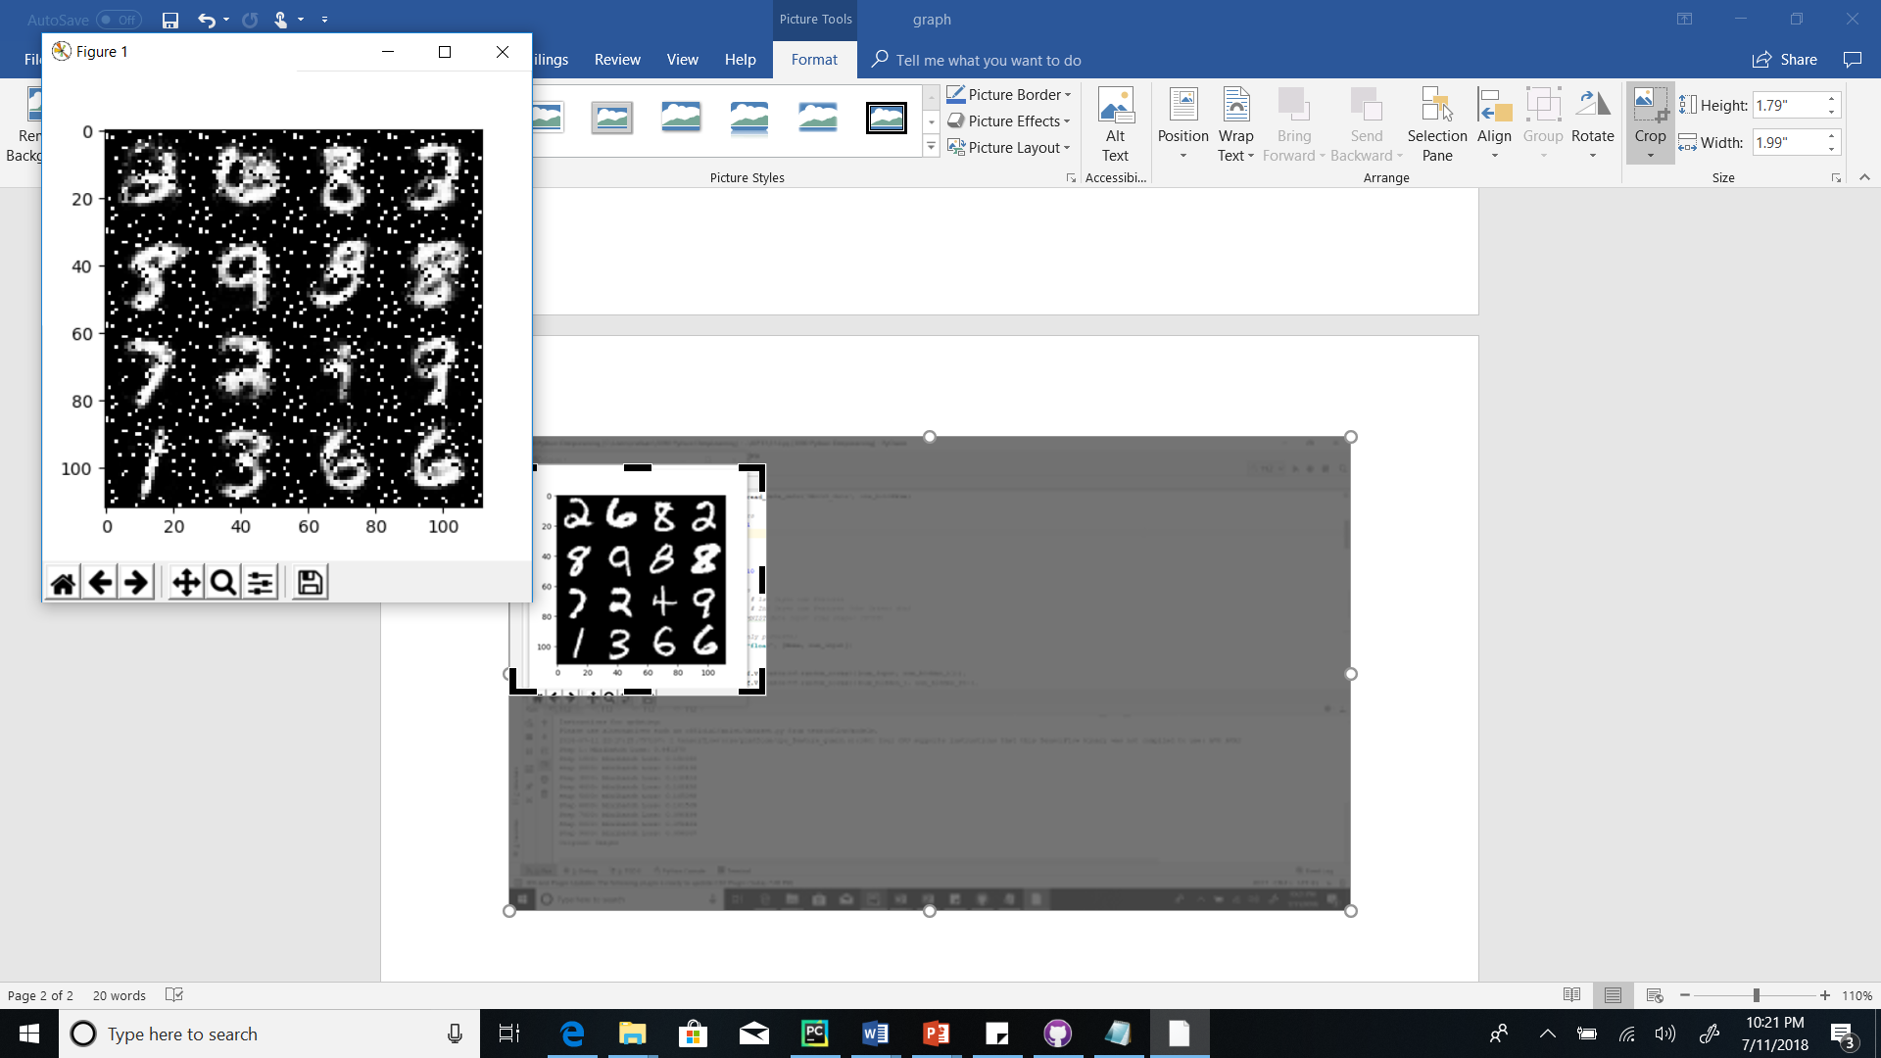

Number of steps = 11

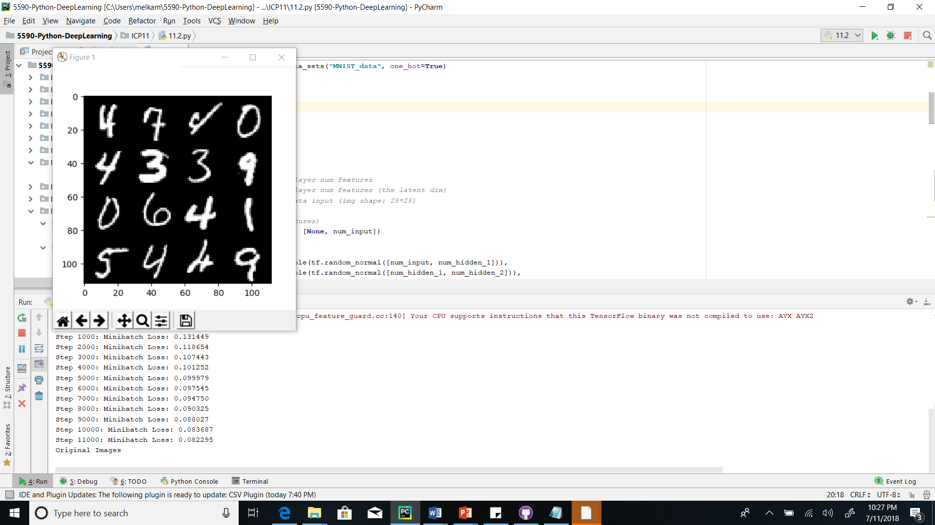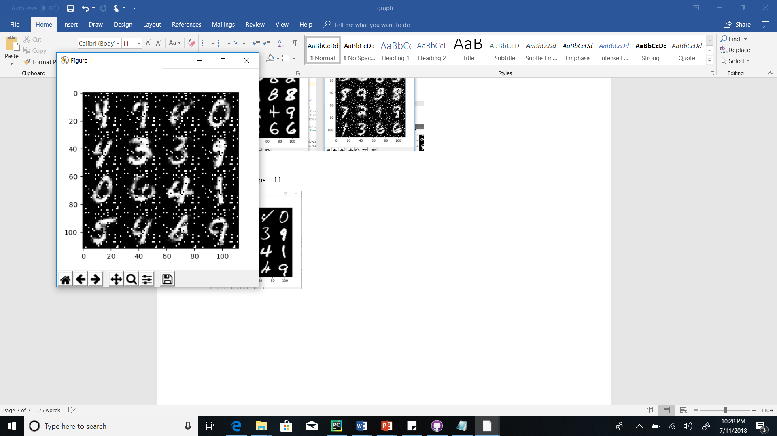

**Conclusion: Increasing iteration/number of steps will minimize loss**

**11.2.4 Changing number of layers**

Constant parameters:

Optimizer = RMSPropOPtimizer

Training steps = 6



Learning rate = 0.01

|  |  |  |  |  |  |  |  |
| --- | --- | --- | --- | --- | --- | --- | --- |
| Number of layers | Step 0 | Step 1 | Step 2 | Step 3 | Step 4 | Step 5 | Step 6 |
| Two layers (L_R=0.01) | 0.434 | 0.129 | 0.105 | 0.102 | 0.092 | 0.090 | 0.083 |
| Three layers  L_R =0.01) | 0.453 | 0.169 | 0.130 | 0.122 | 0.116 | 0.107 | 0.104 |
| Two layers  L_R=0.1 | 0.451 | 0.179 | 0.175 | 0.169 | 0.166 | 0.169 | 0.167 |
| Three layers  L_R=0.1 | 0.450 | 0.175 | 0.168 | 0.162 | 0.163 | 0.163 | 0.162 |

Three layers

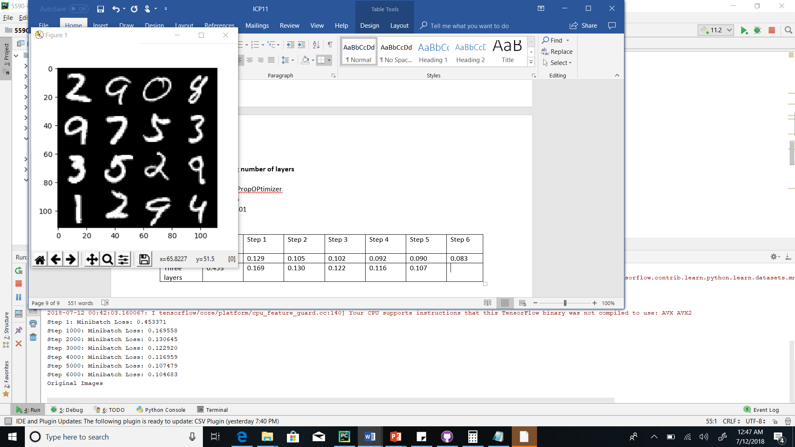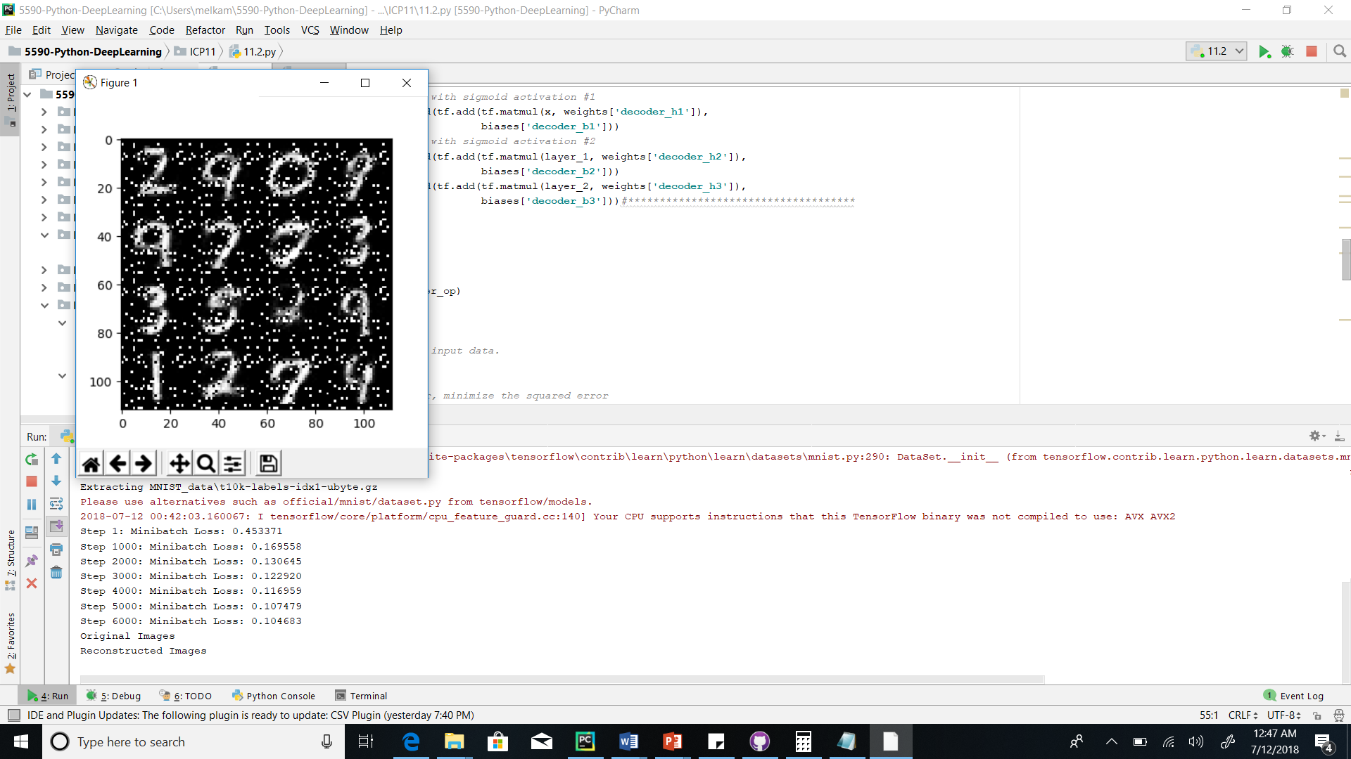

Two layers



Three layers

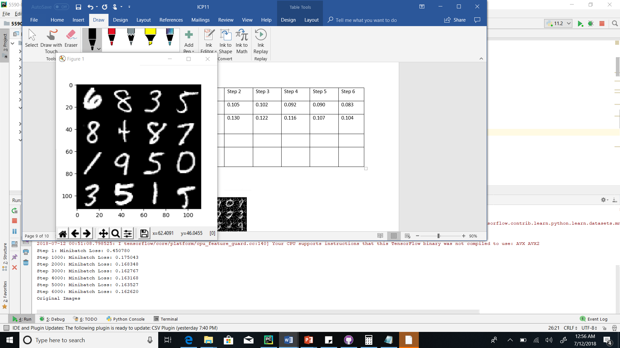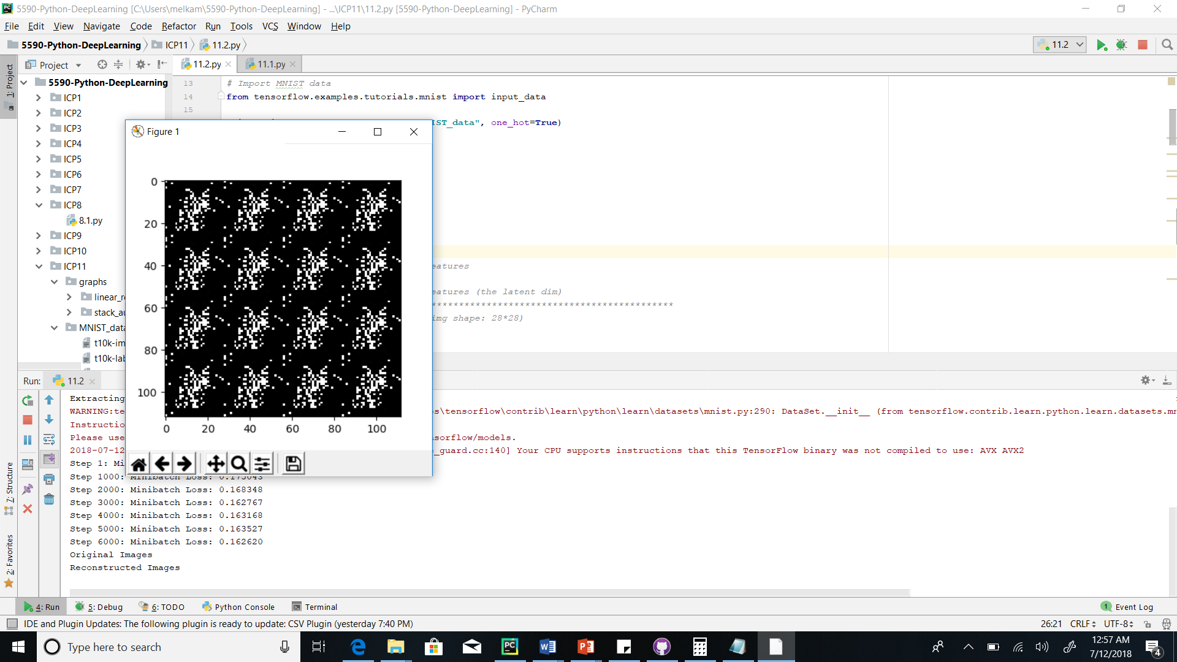

Two layers



Conclusion: At lower learning rate using two layers stacked autoencoders is better.

